|  |
| --- |
| SAVCHENKO INC |
| Space Escapades |
| **Game Concept and Proposal** |
| Version #0.1  All work Copyright © 2012 by SAVCHENKO INC.  All rights reserved. |
| **George Savchenko** |
|  |



|  |
| --- |
| May 16th 2012 |

**Table of Contents**

Table of Contents

Version History 3

I. Game Overview 4

I. Game Play Mechanics 4

*II.* Camera 4

III. Controls 4

IV. Interface Sketch 44

V. Menu and Screen Descriptions 44

VI. Game World 4

VII. Game World Game Progression 5

VIII. Characters 5

IX. Enemies 5

X. Abilities 5

XI. Scoring 5

XII. Story Index 5

XIII. Art / Multimedia Index 5

XIV. Design Notes 6

XV. Future Features 6

Version History

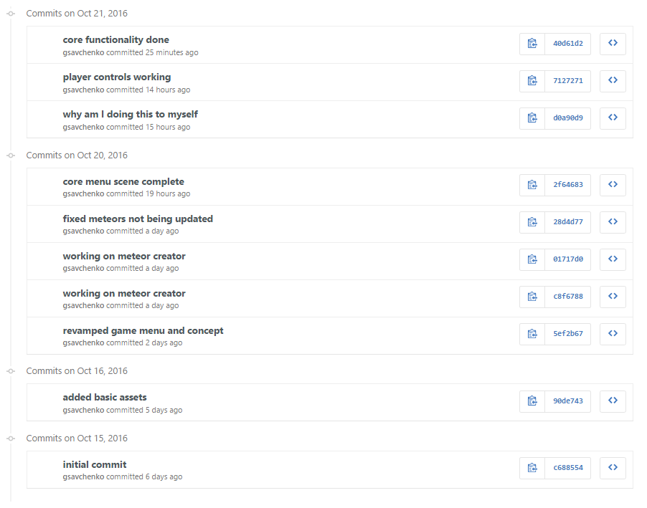

1. Game Overview

*You play as an astronaut trying to avoid falling meteors. Your score is measured by the length of time without getting hint by a meteor. The goal is to get the highscore.*

1. Game **Play** Mechanics

*Player as an astronaut stuck on the moon dodging falling asteroids. The longer you dogde them the higher your score goes. If you get hit you lose.*

1. Camera

*2D Game Environment*

1. Controls

*Standard keyboard and mouse controls.*

1. Interface Sketch

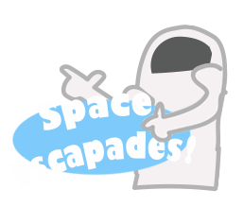

1. Menu and Screen Descriptions

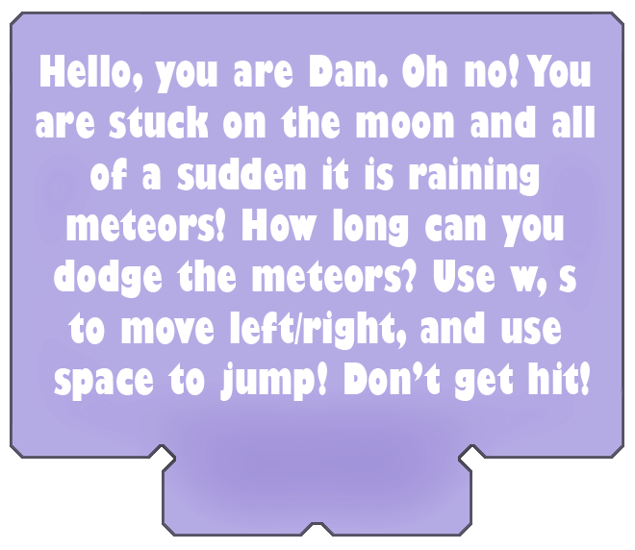

1. Game World

*The game world is a 2D environment set on the moon.*

1. Game World Game Progression

*As the game goes on an increasing number of meteors of increasing falling speed should overwhelm the player.*

1. Characters

*Spacesuit astronaut dude.*

1. Enemies

*Meteors falling to kill you.*

1. Abilities

*Jump and float down due to gravity.*

1. Scoring

*The longer you stay alive the higher your score gets. Timer based.*

1. Story Index

* *You are Dan*
* *You are stuck on the moon*
* *There’s a sudden meteor shower on said moon*

1. Art / Multimedia Index

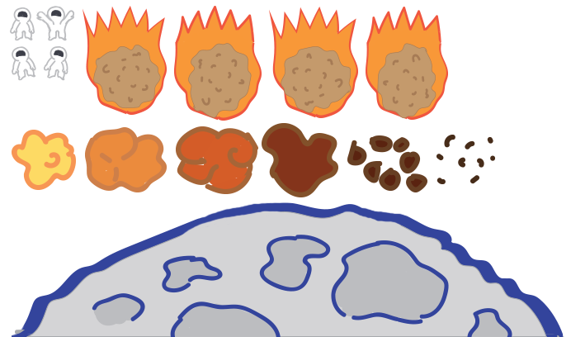

**

1. Design Notes

*Cartoonish-something*

1. Future Features

*Difficulty scaling*

*Better software architecture*